**Group members**

**Katlego Mokoena st10104646, Maxine Van Der Ross st10102495, Ntokozo Nyembe st10099936, Faith Akani Ndlovu st10108031, Tyrique Thomas st10100566**

opsc6311 Read me file

READ ME FILE:

First step is installing the app , with no threats found.

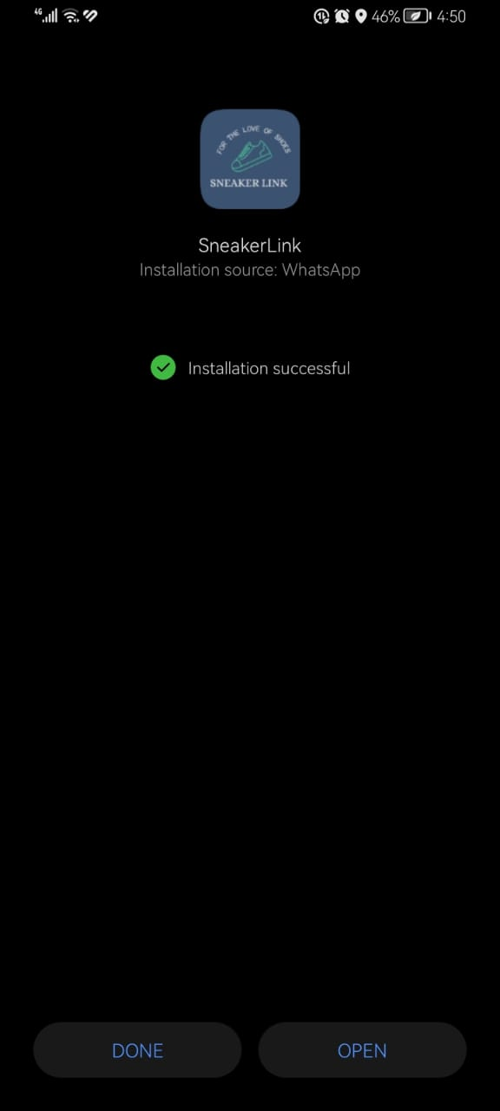

Sign Up Page- The sign up page asks the user to provide the First Name and Last name, then the user creates a password and is required to confirm the password

This is Our Login page that allows the user to enter their username and password and provides a button then to proceed.

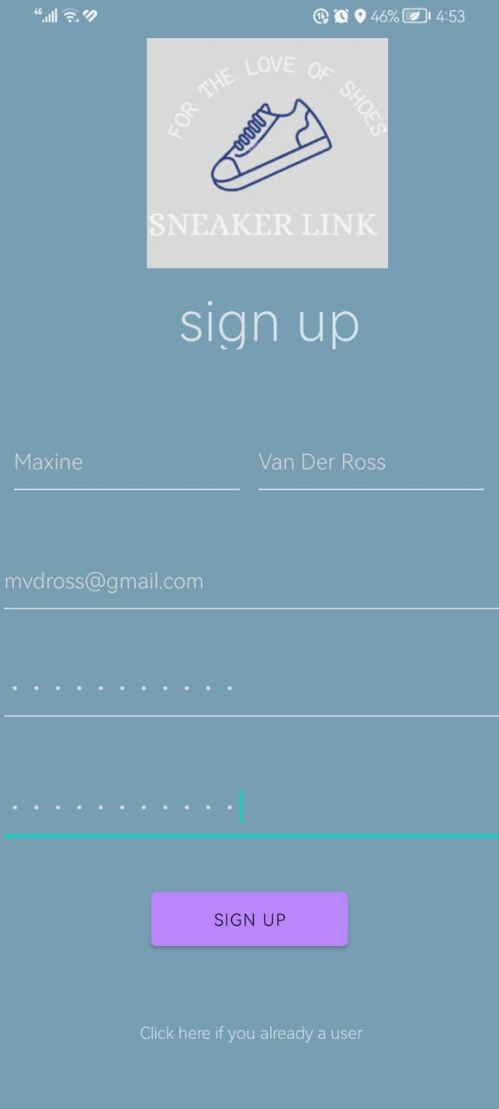

If the user does not have a log in, they can sign up with the necessary credentials and create their own password

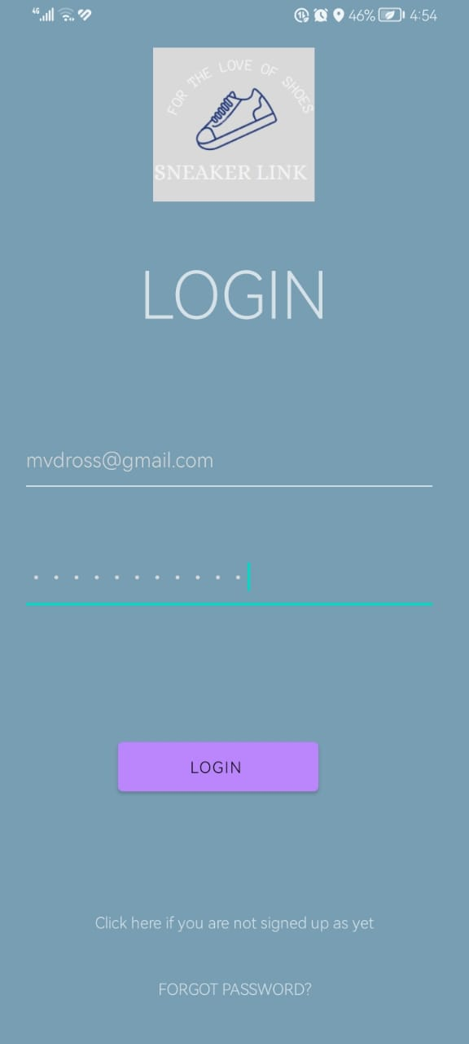

This is Our Login page that allows the user to enter their username and password and provides a button then to proceed.

Once signed up and logged in the user will be taken to the main menu where they’re presented with 3 buttons that’ll take them to the Categories, sneaker Links, New Items pages

In the Categories page there’s a button that’ll allow them to create a category

When creating a Category, the user will have to fill in the sneaker details as well as setting a goal for how many sneakers they want in that category.

This page displays the completed creation of a category with the progress bar that will show you how far the user is to completing their goal for the category. At the bottom of the page there’s a button that’ll allow the user to add items to the category

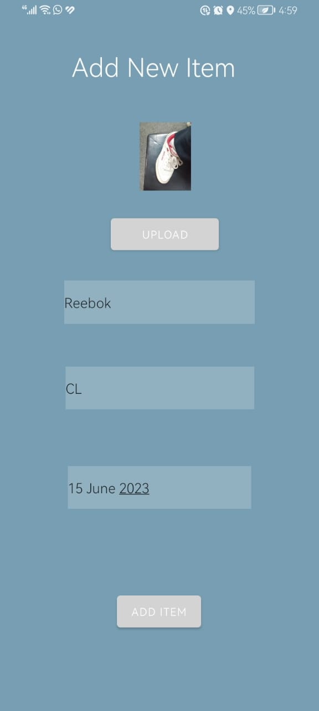

When adding items to a category, the user will fill in the necessary details for the sneaker as well as the date it was added

Once the item is added, the progress bar increases

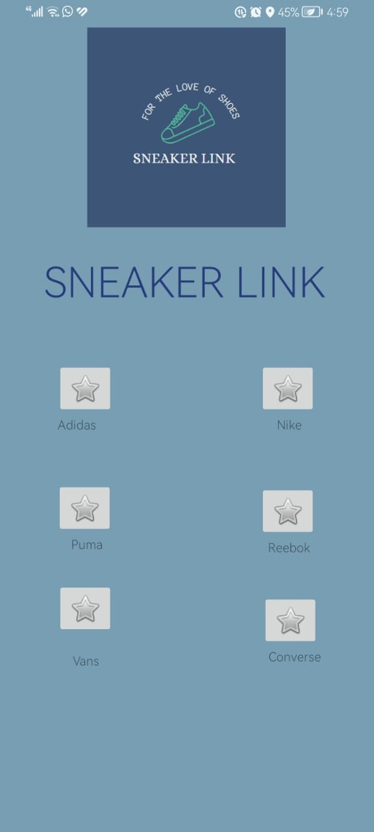

This is the sneaker Links page where, the user can click on a sneaker brand’s button and be redirected the that specific brands website.

This is the Firebase database which we created to store data collected in the application

This stores the user’s credentials

This stores the different categories that the user creates